Lindab UltraLink Controller FTCU

Description text: Ventilation Products

  - Manufacturer: Lindab, type FTCU

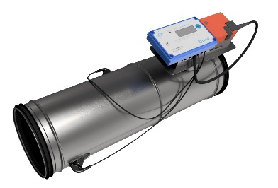
Description text
FTCU is suitable for measuring air flows and temperature in circular ducts. The FTCU can also control the air flow using a motorized damper that is part of the product. It measures the air flow via ultrasonic signals that can be calculated and compensated for a very high accuracy over a large flow range. This method is very stable over time, as it is not sensitive to dust or particles. The design minimizes dust collection on the flow sensors. FTCU causes minimal pressure drop and minimal sound generation, since there is no obstruction in the air flow except the damper blade. It consists of a sensor body with two transducers, a damper body, an electric motor and a display.

When mounting, the FTCU must be positioned so that the display unit is clearly visible from a suitable direction and the sensor body is positioned so it gives best air flow accuracy according to the instruction.

The following parameters can be shown in the display:
- Actual air flow (m3/h)
- Actual air flow (l/s)
- Actual air velocity (m/s)
- Actual Temperature (°C)
- Damper position (%, 100% = fully open)
- Current set point (m3/h)
- Current set point (l/s)
- Current set point (m/s)
- FTCU ID number

Power supply is 24 V AC / DC, power requirement is 0.5 VA for the display. The damper motor's power requirements depend on the product's dimension, see technical documentation.

The product complies with tightness class D according to EN 12237, EN 1751 and EN 15727.

Measurement uncertainty is, depending on which is greater, ± 5% or ± X l / s, where X corresponds to different values ​​depending on the dimension of the product, see technical documentation. Follow the installation instructions carefully to ensure accurate measurement. The accuracy of the measurement is guaranteed for air speeds between 0.2 to 15.0 m / s and for temperatures between -10 and + 50 ° C.

FTCU can be used as "stand-alone" or connected to a BMS via Modbus or analog signals. The digital signals use RS485 with LIYCY cables. It also has Bluetooth, which enables simple and easy commissioning.

Material and dimensions
The body of the product is as standard made of galvanized steel according to EN 10346 with zinc thickness corresponding to Z275. The material fulfils corrosion class C3.

FTCU can also be delivered in other material and finish (Ø 100 – 315):
• White (RAL 9003)
• Black (RAL 9005)
• Stainless steel 4404 (acid-proof)

FTCU is a product in the Lindab Safe family, which means that it has a double-lipped, factory-installed gasket in EPDM rubber.

The product's display unit is produced in plastic and has an IP44 rating.

Dimensions:
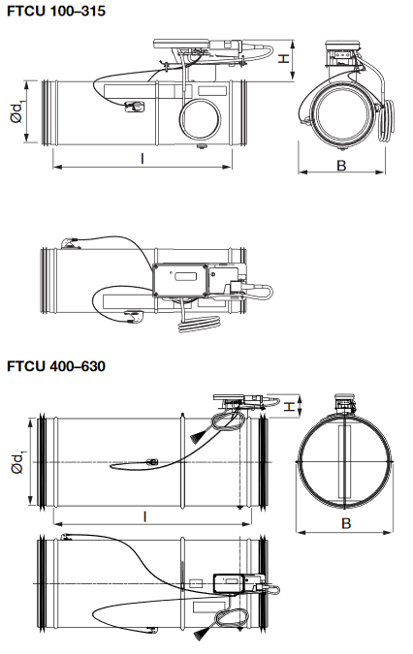
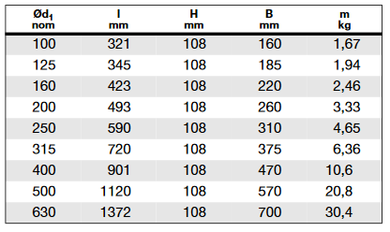

Technical data
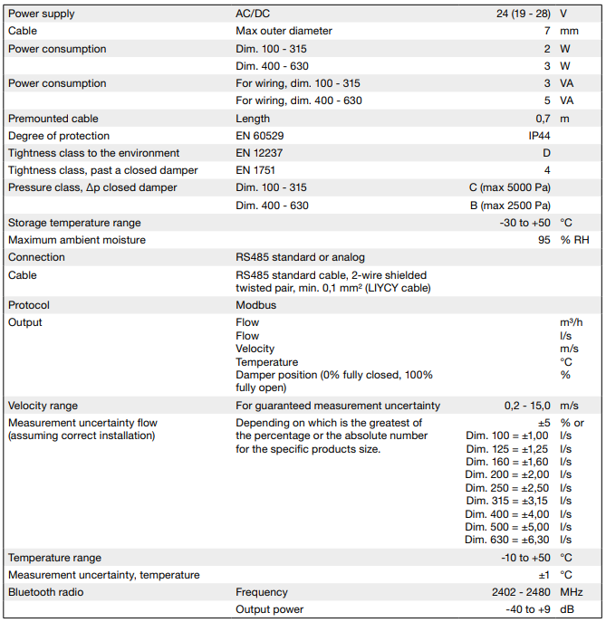
Maintenance
Normally requires no maintenance.

The visible parts of the unit can be wiped with a damp cloth.

Lindab UltraBT™– Room Control DCV system
Connect your FTCU to Lindab OneLink app, and you can use selected wireless sensors SECTH or SEPTH to control the air flow of your ventilation system, by using the UltraBT function. This system comes with a fully integrated Bluetooth technology in all products.

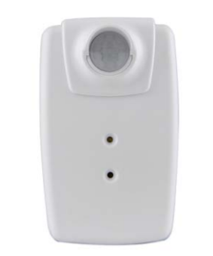
Description text - SEPTH
Bluetooth sensor – presence, temperature, relative humidity

The SEPTH sensor, detects movement using a PIR sensor, and measures temperature and humidity without need for additional compensation – true read

Standard specification
Measured presence, operating principle passive infrared sensor (PIR) Measurements
• Presence 0/1
• Temperature -40–85°C accuracy ±0.4°C (@ -10–85°C)
• Relative Humidity 0-100% accuracy ±4% RH (@ 0– 80% RH, @ 25°C)

Dimensions: ............... 56 x 35 x 23 mm
Battery lifetime expectancy: ........ ~2 years
Power supply:............ 1 x CR2450 Lithium batteries (included)

BLE Bluetooth 4.0 low energy, range >100m with free line of sight Maintenance
Interval: Maintenance-free

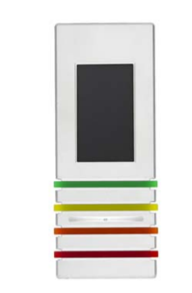
Description text SECTH
Bluetooth sensor – CO₂, temperature, relative humidity
The SECTH sensor, is an advanced and versatile 3-in-1 Indoor Air Quality monitor. It measures CO₂ concentration, temperature and humidity in the ambient air accurately without need for additional compensation – true read. The measured parameters are conveniently combined into one common indicator – the Senseair Index – describing how your performance is affected by the ambient air. Battery lifetime is up to 2 years.
The measured data is shown on a high-resolution display and the overall indoor air quality is intuitively indicated by the stylish LED elements. The data is wirelessly transmitted using an open protocol and can be viewed using a laptop dashboard or a smart phone app.

Standard specification
Measured gas Carbon dioxide (CO₂), operating principle Non-dispersive infrared (NDIR)

Measurements
• CO₂ 400–5000ppm accuracy ±30ppm ± 3% of reading (@15–35°C and 0–80% RH)
• Temperature -40–85°C accuracy ±0.1°C (@25°C), ±1.0°C (@ 0–50°C)
• Relative Humidity 0-100% accuracy ±3% RH (@ 20– 80% RH, @ 25°C)

Dimensions: ............... 148 x 58 x 29 mm
Battery lifetime expectancy: ........ ~2 years
Power supply:............ 2x3.6V AA Lithium batteries (included)

BLE Bluetooth 4.2 low energy, range up to 200m with free line of sight
Display: ...................... LCD memory display with CO₂ (ppm), Temperature (°C) and Humidity (%RH)
-
Maintenance Interval: Maintenance-free

